WEB TECHNOLOGIES

LAB TASK 10



Submitted by: TAHIR AHMED KHAN

Registration No: SP21-BSE-086

Class Section: 6B

Submitted to: SIR HASNAIN IQBAL

Department of computer science

Comsats University Islamabad

Lab Task

Write the JavaScript code (separate for each) of the following:

1. Create an array [2, 4, 6, 8, 10, 12] and then display all those numbers that are less than 5 by using an appropriate method.

Code:

<!DOCTYPE html>

<html lang="en">

<head>

    <meta charset="UTF-8">

    <meta name="viewport" content="width=device-width, initial-scale=1.0">

    <title>Document</title>

</head>

<body>

    <script>

        let myArray = [2, 4, 6, 8, 10, 12];

        let result = myArray.filter(func);

        function func(n){

            return n < 5;

        }

        console.log(result);

    </script>

</body>

</html>

Output:

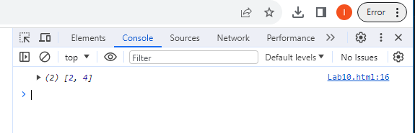

1. Create an array [1, 11, 111] and then subtract numbers from right to left by using a suitable method and display the output.

Code:

<!DOCTYPE html>

<html lang="en">

<head>

    <meta charset="UTF-8">

    <meta name="viewport" content="width=device-width, initial-scale=1.0">

    <title>Document</title>

</head>

<body>

    <script>

        let myArray = [1,11,111];

        let result = myArray.reduceRight(func);

        function func(a,b){

            return a-b;

        }

        console.log(result);

    </script>

</body>

</html>

Output: 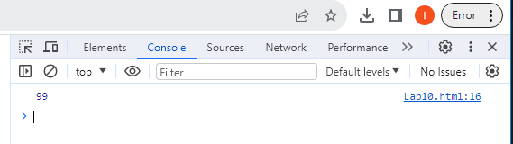

1. Create an array [“Instagram”, “Twitter”, “Facebook”, “Snapchat”, “Instagram”, “LinkedIn”] and then find the last index of “Instagram” from the given array and display that index.

Code:

<!DOCTYPE html>

<html lang="en">

<head>

    <meta charset="UTF-8">

    <meta name="viewport" content="width=device-width, initial-scale=1.0">

    <title>Document</title>

</head>

<body>

    <script>

        let myArray = ["Instagram", "Twitter","Facebook", "Snapchat", "Instagram", "LinkedIn"];

        let result = myArray.lastIndexOf("Instagram");

        console.log(result);

    </script>

</body>

</html>

Output:

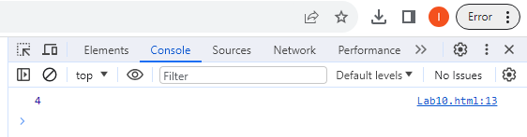

1. Ask the user to enter a number from 0 to 9. If the user enters a number from the given range (from 0 to 9), then display that number. Otherwise, display a message that you (enter your name) entered a number out of range (for example “Hasnain Iqbal enter a number out of range”).

Code: <!DOCTYPE html>

<html lang="en">

<head>

    <meta charset="UTF-8">

    <meta name="viewport" content="width=device-width, initial-scale=1.0">

    <title>Document</title>

</head>

<body>

    <script>

        let num = prompt("Enter a Number");

        if(num>=0 && num<=9){

            alert("Number: "+num);

        }

        else{

            let name = prompt("Enter Your Name");

            alert(name+" enter a number out of range")

        }

    </script>

</body>

</html>

Output:

